

.

Project Documentation Of

eStudiez Portal

Live host at:

<https://estudiez.netlify.app/>

https://github.com/Tomoe-495/eStudies-Portal



Index

# Case Study

1. Definition of Problem
2. Requirement Analysis
3. Design Phase
4. Architecture of Website
5. Documentation Section
6. Source Code
7. User Guide



* + Case Study

Education is a primary necessity and for Parents/Guardians to be updated about their wards, progress is even more important. Students who fail exams might not reveal their marks to their Parents/Guardians because of fear. Teachers, too, are overloaded with work, because of which it

becomes difficult to remember each child’s academic progress. Also, students too must be kept aware of their score progress and mark required for passing External Exams. A Web portal to track all these is a solution.

So as an answer to all these problems we have developed a portal named eStudiez which will have access to all the students' marks. Their parents can also see their children’s report, while the teachers can update their homework and update the marks of the students. Teachers can also upload videos or pictures of their work so that the children can get more information in less time. With the help of this portal children can’t hide their examination marks from their parents and parents can get regular updates.

* + Proposed Solution

We have designed and built a website named eStudiez, intended to track academic progress of a student. This system will allow various types of users such as Students, Parents/Guardians, and Teachers to view and track progress. Students who have fared poorly will be provided additional study resources via this portal to improve their future performance. This portal will also provide information regarding Revision classes that can

help to boost performance. Each student’s progress can be viewed and tracked by Students themselves and their Parents/Guardians.

* + Definition of the Problem

Students who fail in exams might not reveal their marks to their Parents/Guardians because of fear. Teachers too are overloaded with work, because of which it becomes difficult to remember each child’s academic

progress. Also, students too must be kept aware about their score progress and marks required for passing External Exams.

To overcome this problem this portal has been made. After consulting several IT companies and considering the budget constraints, the management of eStudiez has decided to launch the Web application as a Single Page Responsive Web application. Hence, the project will use HTML5, CSS3, JavaScript, Geolocation API. Also, the site will be tested on popular browsers and mobile emulator software.



Requirement Analysis

* + Hardware
* Intel Core i5 Processor or High
* 5GB RAM or above
* Color SVGA
* 120GB Hard Disk Space
* Mouse
* Keyboard
  + Software

Technologies to be Used

* + - Frontend: Html5, CSS, Bootstrap, jQuery, AngularJS and XML.
    - Data Store: JSON files or.txt files



Design Phase

* + Designing the GUI Standards

Multiple Web pages may be created for implementing the project and linked to each other. Each of

these Web pages or forms should have a consistent look with respect to appearance and theme

used. The font styles, color of the labels, design and appearance of the command buttons, the

appearance of header and footer, and the design and size of controls, such as check boxes or text

boxes should be consistent through all the pages.



* + Site Map

Student’s Portal

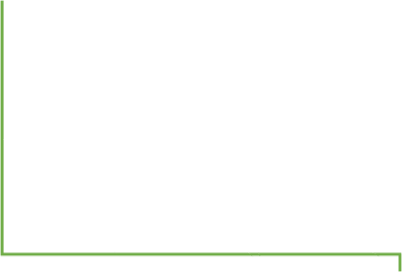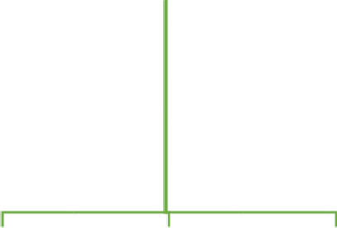

Home

Marks

Student

Marks Page

Progress

Study

Resources

Revision

Classes

Feedback

Contacts

Progress

Page

Resources

Page

Revision

Classes Page

Feedback

Page

Contact

Page



Teacher’s Portal

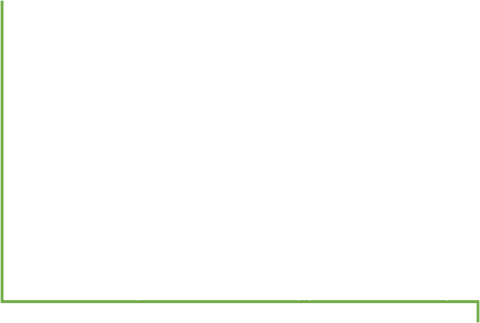

Home

Student's

Mark/Score Updation

Student's Mark

Form

Student's

Academic Progress

Add Study

Resources

Revision Classes

Updation

Feedback

Contacts

Student

Appraisal Form

Study Resources

Form

Resources

Updation Form

Feedback Form

Contact Form



Parents/Guardians Portal



Home

View Marks

Marks Table

View Academic

Progress

Feedback

Contacts

Academic

Progress Table

Feedback Form

Contact Form



Architecture Of Website

Clients

Mobiles

Tablets

Laptops

Frontend Technologies

(HTML, CSS,

Javascript)

Server



Documentation Section

Problem definition –

Students who fail in exams might not reveal their marks to their Parents/Guardians because of fear. Teachers too are overloaded with work, because of which it becomes difficult to remember each child’s academic progress. Also, students too must be kept aware about their score progress and marks required for passing External Exams.

To overcome this problem this portal has been made. After consulting several IT companies and considering the budget constraints, the management of eStudiez has decided to launch the Web application as a Single Page Responsive Web application. Hence, the project will use HTML5, CSS3, JavaScript, Geolocation API. Also, the site will be tested on popular browsers and mobile emulator software.

|  |  |
| --- | --- |
|  | Prepared By Muhammad Sahil |
| Date | 11/08/2022 |

Client/Project Undertaken: eStudiez Portal

1. List of inputs to the system
   * Welcome Message
   * Home Page
   * Feedback Form
   * Contact Form
   * Updating of homework and marks
2. List of outputs expected from the system
   * Parents getting known about their children
   * Children getting updated about their homework
3. Hardware and Software required for implementing the project
   * Hardware
4. Intel Core i5 Processor or higher
5. 5 GB RAM or above
6. Color SVGA
7. 120 GB Hard Disk space
8. Mouse
9. Keyboard

### Software

1. Frontend: HTML5, CSS, JavaScript, jQuery,
2. Data Store: JSON files or TXT files

|  |  |
| --- | --- |
|  | Prepared By Muhammad Sahil |
| Date | 11/08/2022 |



|  |  |
| --- | --- |
| S.No. | Customer’s Acceptance Criteria |
| 1. | Welcome Message Done |
| 2. | Student Portal Done |
| 3. | Teacher’s Portal Done |
| 4. | Parent’s Portal Done |
| 5. | Feedback and Contact Done |
| 6. | Visitor Count Done |
| 7. | Scrolling Ticker Done |
| 8. | Parents can view their children marks |

|  |  |
| --- | --- |
|  | Prepared By Muhammad Sahil |
| Date | 11/08/2022 |



Project Plan

1. Project Details
   * Name of the Client: TechWiz
   * Date of the Project Plan: 12/08/2022

### Project Vision/Objectives:

eStudiez Portal is proposed as an online support portal for users (Students/Parents/Guardians/Teachers).

### Scope:

This Web portal will be a responsive and visually appealing Website to be used by individuals (Students, Parents/Guardians, and Teachers).

### Our understanding of the client organization

eStudiez Portal is proposed as an online support portal for user (Student s/Parents/ Guardians/ Teachers).

* + Project Organization with Responsibilities and Authorities

|  |  |  |
| --- | --- | --- |
| Project Team Members | Their Roles | Their Responsibilities |
| Muhammad Sahil |  | Documentation/HTML Tables |
| Muhammad Hasnain Siddique | Leader | HTML/CSS/JavaScript |
| Asad Mahmood |  | HTML/CSS/JavaScript |
| Yamna Iqbal |  | HTML/CSS |
| Yusra Iqbal |  | HTML/CSS |

3. Deliverables (The documents to be handed over to the client – such as CRS, Design Document, Installation Manual, User Manual, Maintenance Manual, and Code of documents)

A User Manual will be given to the client for operating the portal. 1. Source Code

1. Documentation
2. Web Pages
3. Source Images
4. Source Audios
5. Source Videos
6. Project Dependencies (Any event or task outside the scope of the project which will affect the success of the project)

This Portal will work on Windows, Linux and Mac Servers.

1. Quality Plan
   * Review Activities (Review meeting participants, frequency and so on) We have reviewed all the activities and the portal has been reviewed.
   * Testing Activities (Final Test)

We have tested the portal and it has been successfully completed and we are satisfied with its results.

* + Backup and Recovery Strategies (In case of disk crash, network failures, and so on)

In Case of an unexpected disk crash or network failure we have provided you with the website URL on which it is hosted link from which you can easily locate the portal.

Link: <https://estudiez.netlify.app/>

|  |  |
| --- | --- |
|  | Prepared By Muhammad Sahil |
| Date | 11/08/2022 |

|  |  |
| --- | --- |
| Property | Value |
| Document Theme and Color Scheme | CSS |
| Form-Background Color | Picture |
| Title-Font Size |  |
| Title-Font Color |  |
| Title-Font Style |  |
| Title-Alignment |  |
| Background color of Controls on the form |  |
| Foreground color of Controls on the form |  |
| Control Caption  Font Size |  |
| Control Caption Font Color |  |
| Control Caption Font Style |  |
| Control caption and controls-Alignment |  |
| Command button-Alignment |  |

|  |  |
| --- | --- |
|  | Prepared By Muhammad Sahil |
| Date | 11/08/2022 |

1. List of forms to be created

|  |  |  |
| --- | --- | --- |
| Page/Form Name | Description | Controls on the Page/Form |
| Contact Form | It has been made for the parents/ guardians, teachers and students to ask anything. | Text- box,buttons |
| Feedback Form | It has been made for giving feedback about the portal. | Text-box and buttons |
| Student’s Marks/Score Updating Form | This form has been made for the teachers for updating student marks. |  |
| Student Academic Progress | This form has been made for the teachers to update students’ academic progress |  |
| Revision Classes Updating Form | This form will help the teachers to update the schedule of the revision classes |  |

|  |  |
| --- | --- |
|  | Prepared By Muhammad Sahil |
| Date | 11/08/2022 |





1. Process/Module Name
2. Process/Module Description and Details

|  |  |
| --- | --- |
|  | Prepared By Muhammad Sahil |
| Date | 11/08/2022 |

|  |  |  |  |  |  |  |
| --- | --- | --- | --- | --- | --- | --- |
| **Date:** | **Project Plan/**  **Milestone** | **Work Specification** | **Status of the Activity** | **Remarks** | **Responsibility** |  |
| 10-August-2022 | * Home page * Contact page   ∙ | Create structure and design | completed | Task is completed on  time | Muhammad Sahil Yamna Iqbal Yusra Iqbal Asad Hasnain | |
| 11-August-2022 | . Feedback Form  . Study Resources Page | Create structure and design | completed | Task is completed on  time | Muhammad Sahil Yamna Iqbal Yusra Iqbal Asad Hasnain | |
| 12-August-2022 | ∙ Teachers Portal  . Parents Portal  . Documentation | Create structure and design | completed | Task is completed on  time | Muhammad Sahil Yamna Iqbal Yusra Iqbal Asad Hasnain | |

|  |  |
| --- | --- |
|  | Prepared By Muhammad Sahil |
| Date | 11/08/2022 |

**Final Check List**

|  |  |  |
| --- | --- | --- |
| **Design Plan:** | **Document Name: Final Check List** | **SWD/Form No. 8** |
| **Effective Date:** | **Version: 1** | **Page No.** |

|  |  |  |
| --- | --- | --- |
| **S.No** | **Aspect Tested** | **Suggestion/Remarks** |
| 1. | Have all the modules been properly integrated and are they completely functional? | yes |
| 2. | Does each unit meet its objective and purpose? Are all the validations happening properly? | yes |
| 4. | Is the GUI design consistent all over? | yes |
| 5. | Are the codes working as per specification? | yes |
| 6. | Does the application’s functionality resolve the client problem, and satisfy his/her needs completely? | yes |
| 7. | Have the hardware and software been correctly chosen? | yes |
| 8. | Additional features and utilities that give value addition to the entire project. | Yes |

|  |  |
| --- | --- |
|  | Prepared By Muhammad Sahil |
| Date | 11/08/2022 |



# **Source Code**

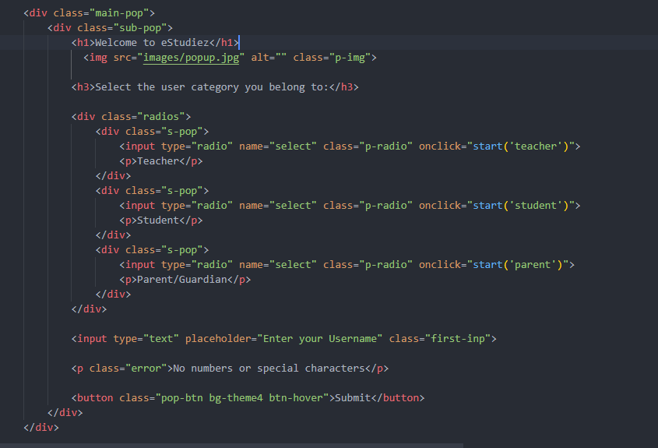

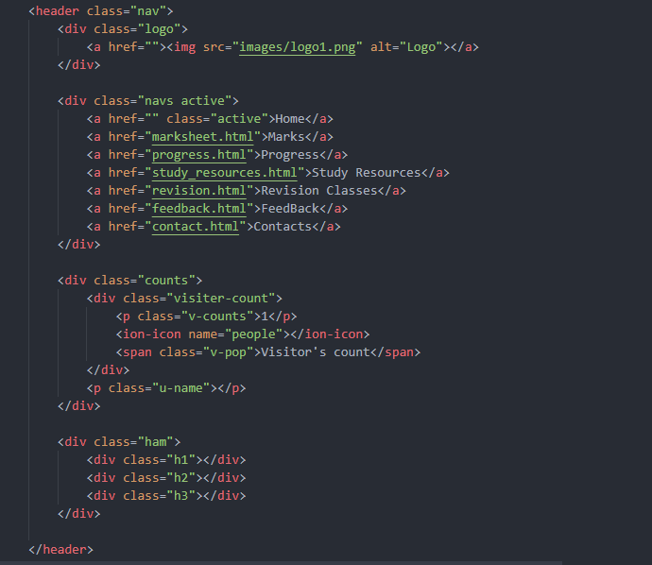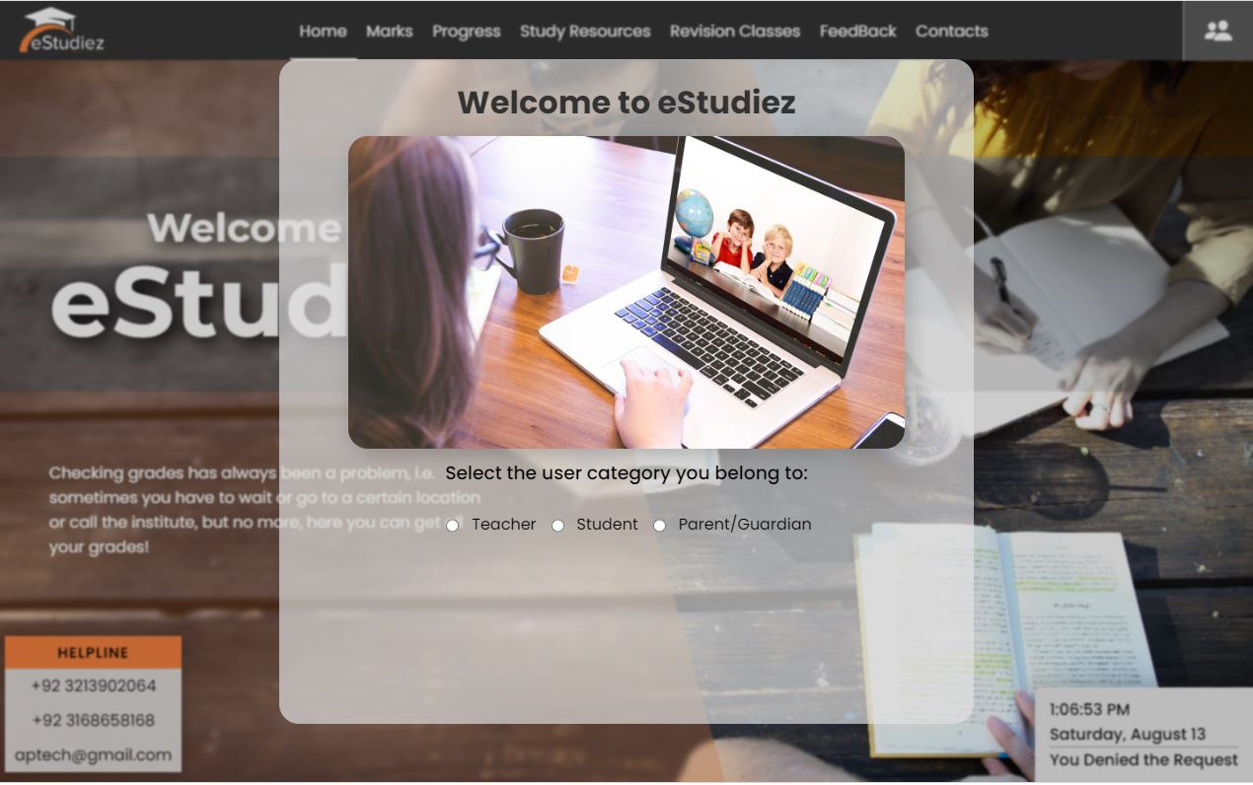

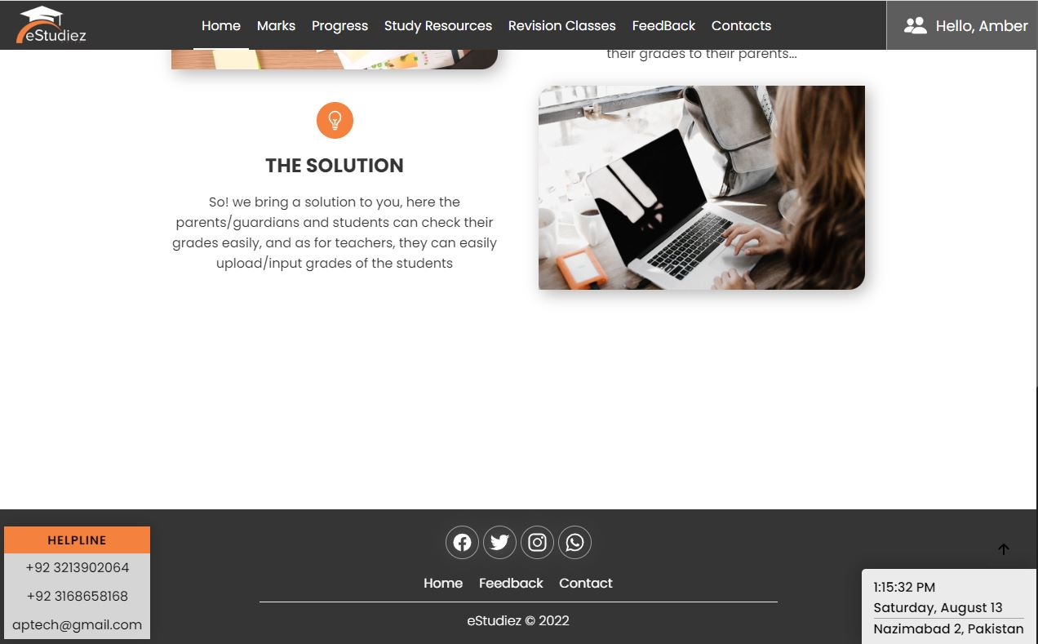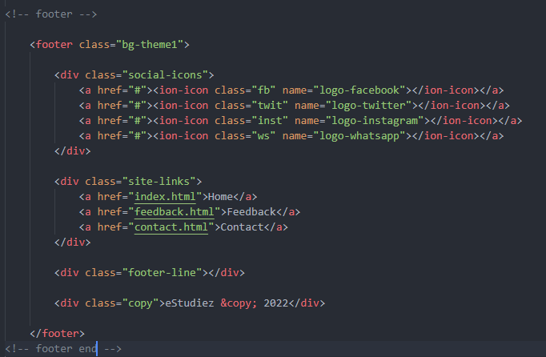

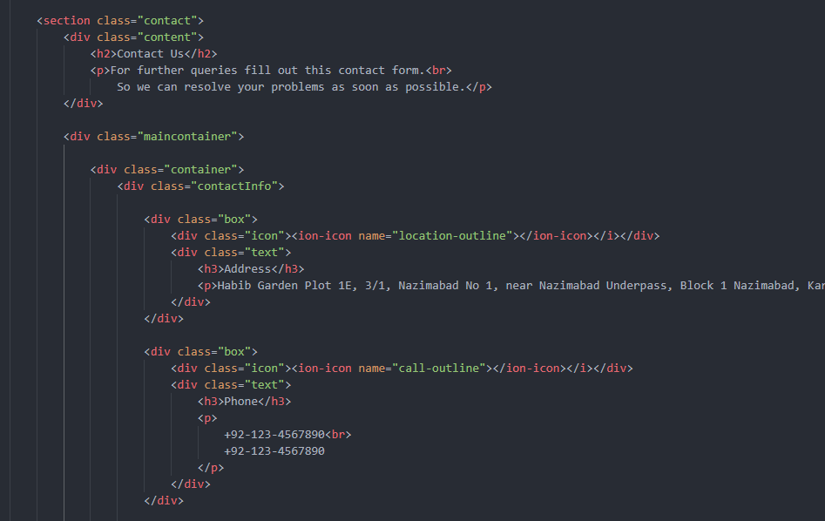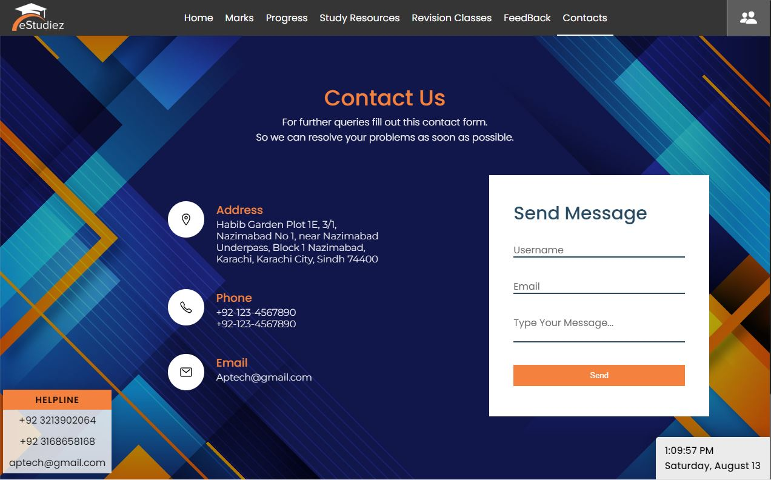

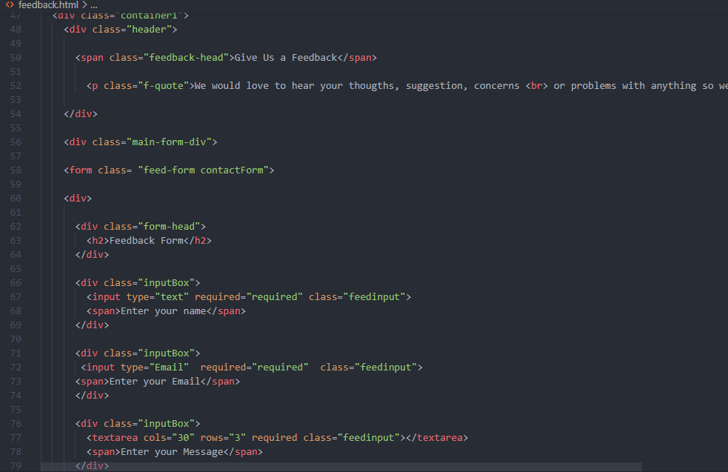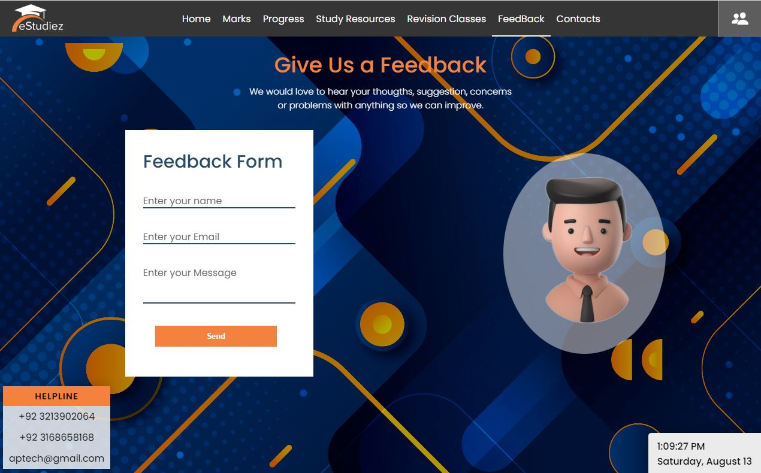

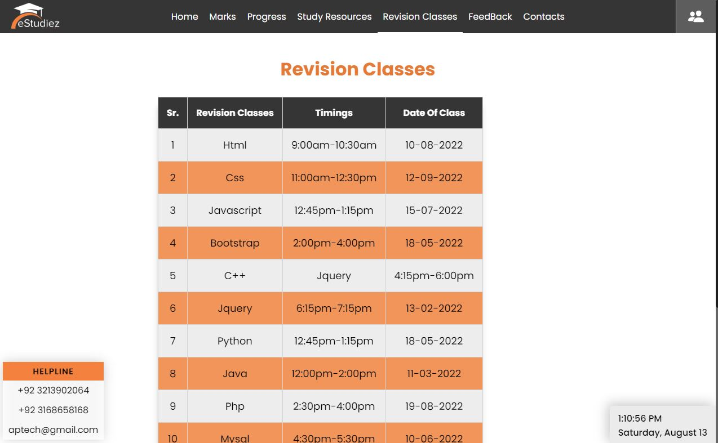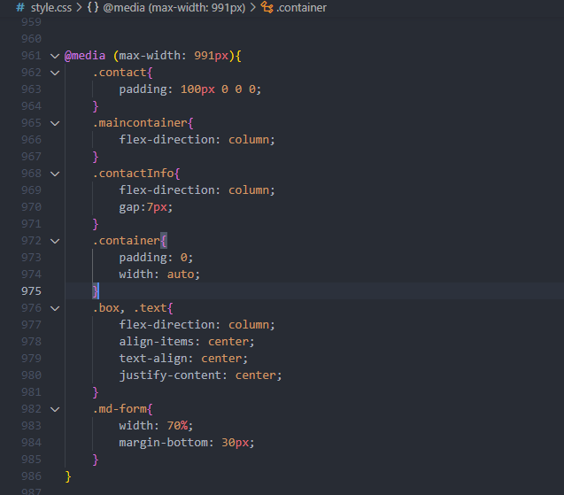

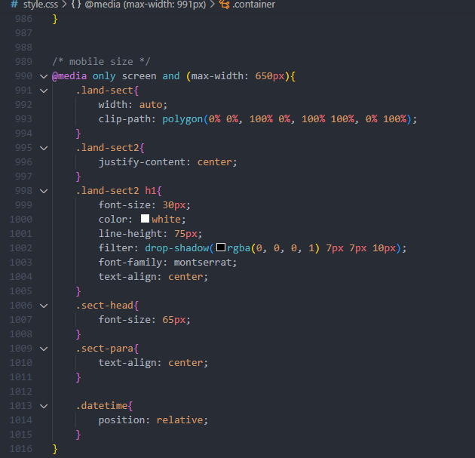

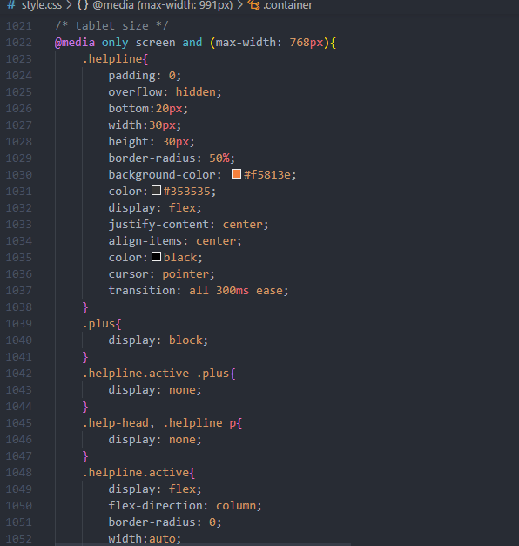

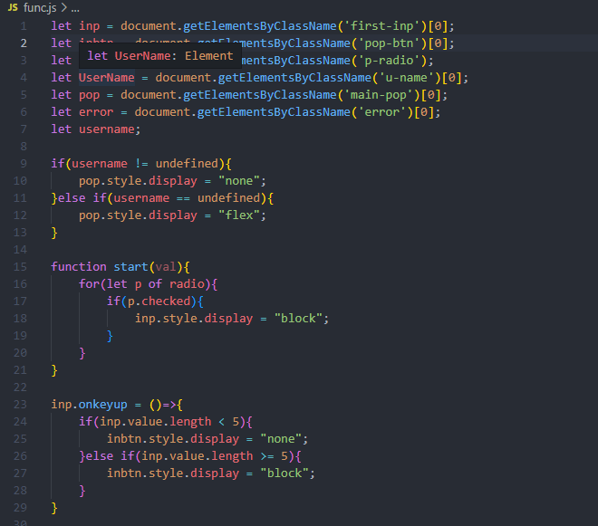

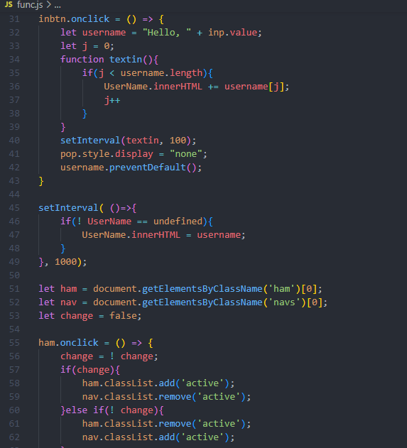

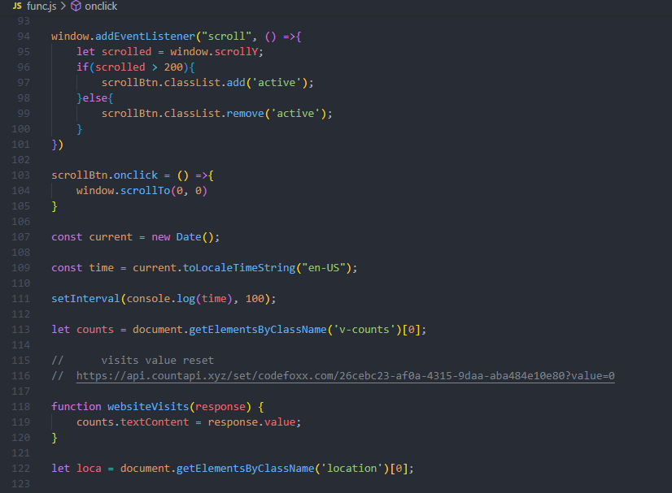

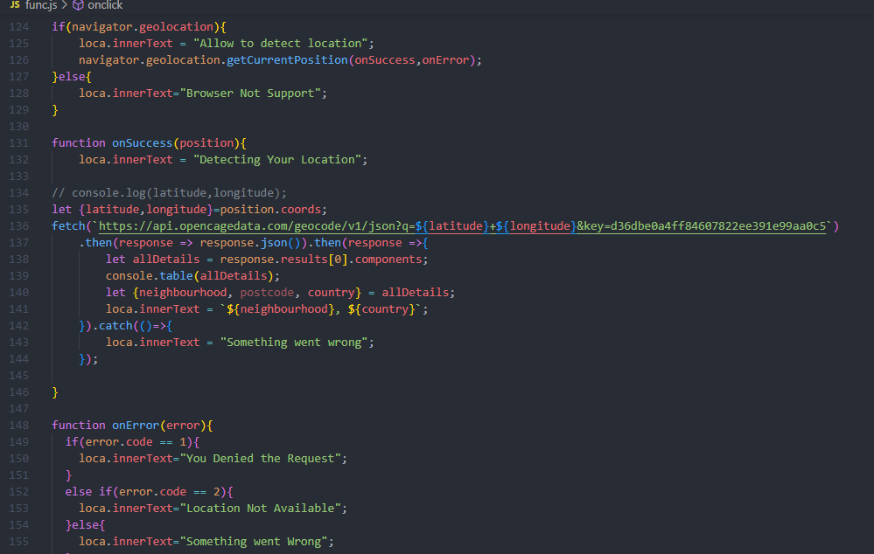

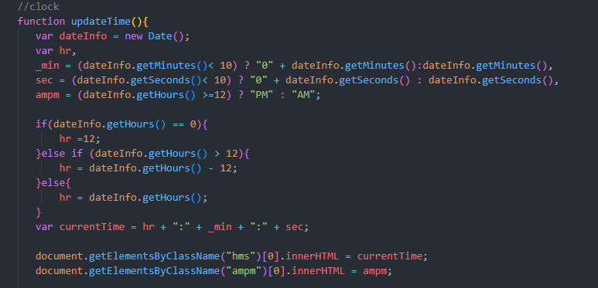

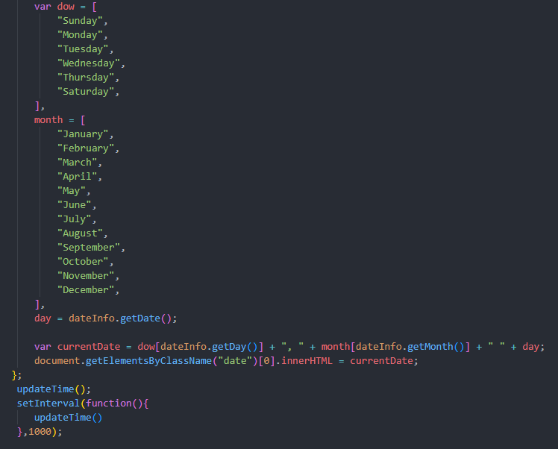

**Source Code End**

* + Site Hosting

User Guide

<https://estudiez.netlify.app/>

https://github.com/Tomoe-495/eStudies-Portal

* + System Requirements

## Hard Ware

* + - Intel Core i5 Processor or higher
    - 5 GB RAM or above
    - Color SVGA
    - 120 GB Hard Disk Space
    - Mouse
    - Keyboard
  + Software
    - Frontend: Html 5, CSS, JavaScript, jQuery
    - Data Store: JSON files or TXT files



